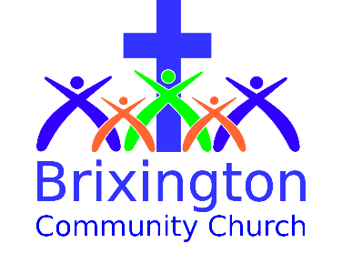

Gift Aid Declaration

Please treat as Gift Aid donations all qualifying gifts of money made
Today in the past 4 years in the future

Please tick all boxes you wish to apply.

I understand the charity will reclaim 25p of tax on every £1 that I give.

I confirm I am a UK taxpayer. I have paid or will pay an amount of Income Tax (and/or Capital Gains Tax) for each tax year 6 April-5 April that is at least equal to the amount of tax that all the charities that I donate to will reclaim on my gifts for that tax year. If I pay less tax than the amount of Gift Aid claimed on all my donations it will be my responsibility to pay any difference to HMRC.

Donor's details

Title............ First name or initial(s).....................................

Surname.....................................................................

Full home address ..................................................................................

..............................................................Postcode..........................

Signature................................................Date.................................

Please notify the Church Treasurer if you:
- Want to cancel this declaration
- Change your name or home address
- No longer pay sufficient tax on your income andlor capital gains
- If you pay Income Tax at the higher or additional rate, to receive the additional tax relief due to you, you must include all your Gift Aid donations on your Self Assessment tax return or ask HM Revenue and Customs to adjust your tax code

Dated 6/20

